Greenhouse Environmental System: SpecC Refinement Rules
Specification Model Guidelines
- Separate communication and computation – We have separated all communication functions from computational functions. All computations are performed in separate leaf behaviors, while communication between each behavior (and passing of any variables/events/flags) is done via c_queue channels.
- Expose parallelism – All behaviors, at the specification level, operate concurrently within our system. At the specification model, we are allowing all behaviors to essentially run independently of one another, relying only on the data dependencies that are passed through each communication channel.
- Use hierarchy to group related functionality – This modeling guideline is most evident in our use of multiple levels of sub-behaviors within the temperature and moisture processing functions to perform both our check against the temperature/moisture settings and the control of the heater/sprinkler units. The individual leaf behaviors for the cumulative temperature processing function are captured in a “Temp Processing” sub-behavior (leaf behaviors executing in parallel), which are executed in the “Climate Control” system.
- Choose proper granularity – For our specification model, we attempted to create our leaf behaviors in such a way that we could maximize our optimization possibilities once we began to perform architectural and communication refinement steps. This allows us to mix and match the partitioning of our system onto different PEs as we move through the refinement process.
Refinement Rules for Behavior Partitioning
- Bind behaviors to components – We used the SCE tool to bind behaviors to specific PEs, using estimation metrics to determine which behaviors should logically be grouped together and which potential PE implementations were most logical for the system.
- Group behaviors – Using SCE, we grouped the component behaviors to the PEs to which they had been allocated.
- Estimate behavior metrics – We used the SCE tool to estimate the behavior metrics of our system, using the profiling results SCE provides to get an idea of what types of PEs should be used in our embedded system (Figs 1-4). A number of different configurations and combinations were evaluated, using both the Motorola DSP and Custom HW components from HW #2. These included a SW only configuration (Fig 5), a HW only configuration (Fig 6), and then three SW/HW co-configurations. The three configurations were:
  - Read Settings, Heat Control, and Sprinkler Control all mapped to Custom HW components (Heat Control and Sprinkler Control on same HW), with TempProcessing and MoistProcessing on a DSP
  - Read Settings on Custom HW, everything else on DSP
  - Read Settings on Custom HW, Process_Temp and Process_Moist on separate DSPs
The metrics for Option 2 are shown below (Fig 7-8). These metrics are nearly identical to Option 3, with the exception that the metrics for the DSP implementation are split onto two separate DSPs.
Note: Diagrams of all three architecture models are captured in the Architectural Model Diagrams file, though only the third (1 HW, 2 DSP) was evaluated all the way through the architectural refinement process. This configuration was selected
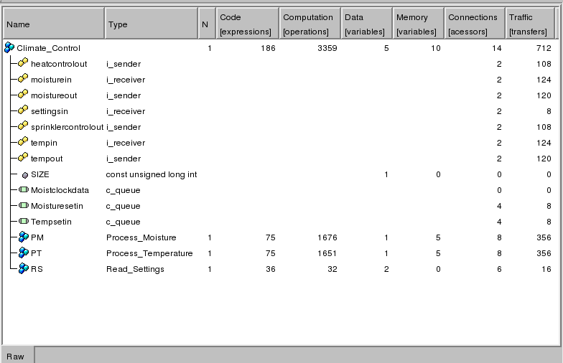
Figure 1. Profiling Results for “Climate Control”
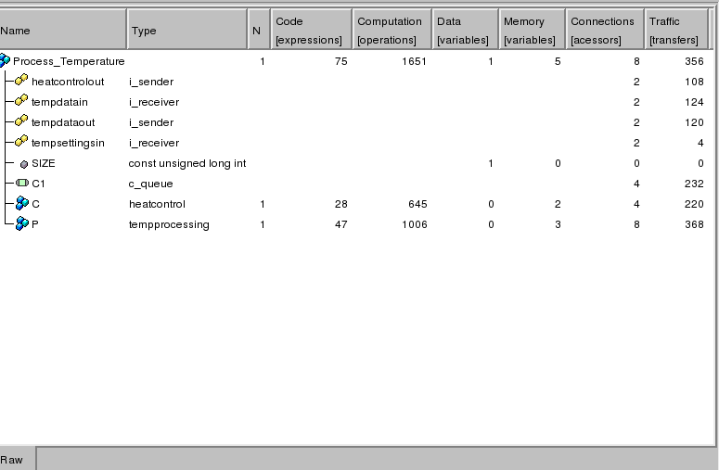
Figure 2. Profiling Results for “Process_Temperature”
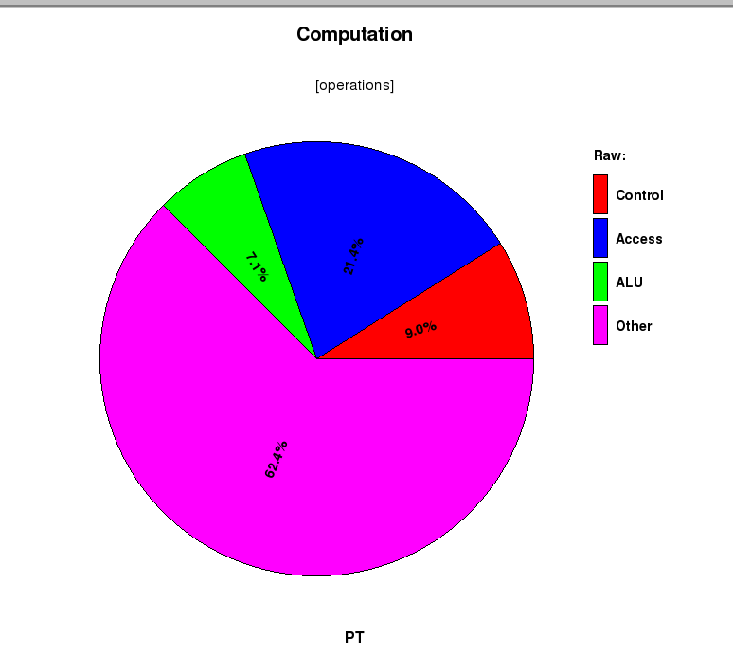
Figure 3. Distribution of Computational Operations for “Process_Temperature”
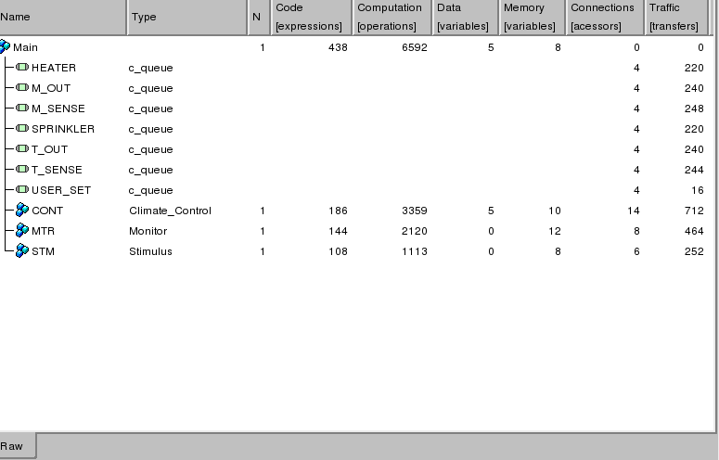
Figure 4. Profiling Results for Climate Control plus Testbench

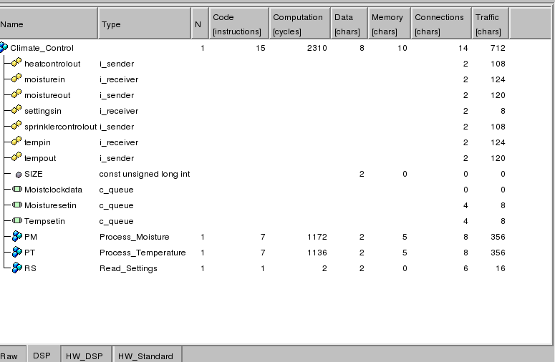
Figure 5. Profiling of Software-Only Implementation

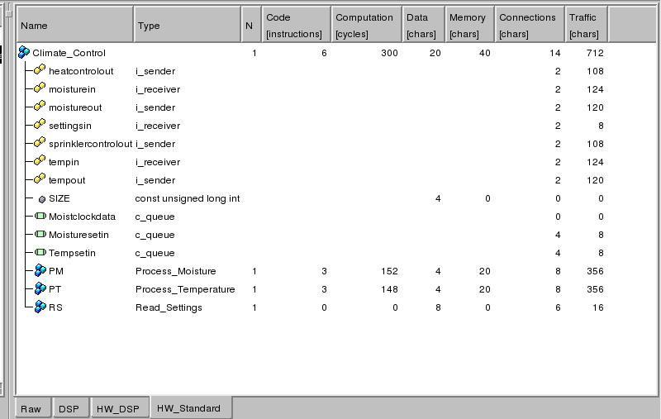
Figure 6. Profiling of Hardware-Only Implementation

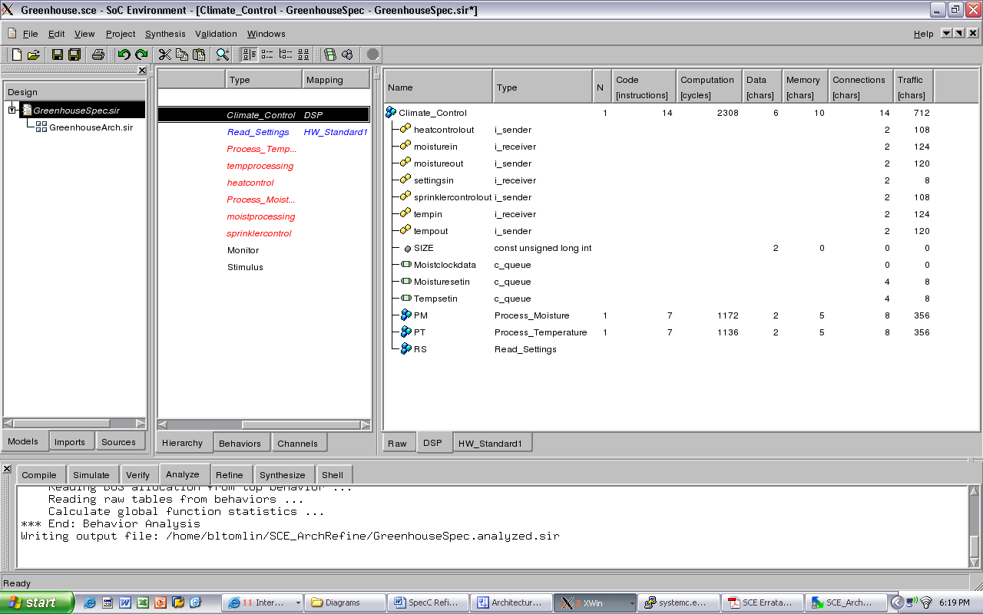
Figure 7. Profiling of DSP for HW/SW Implementation

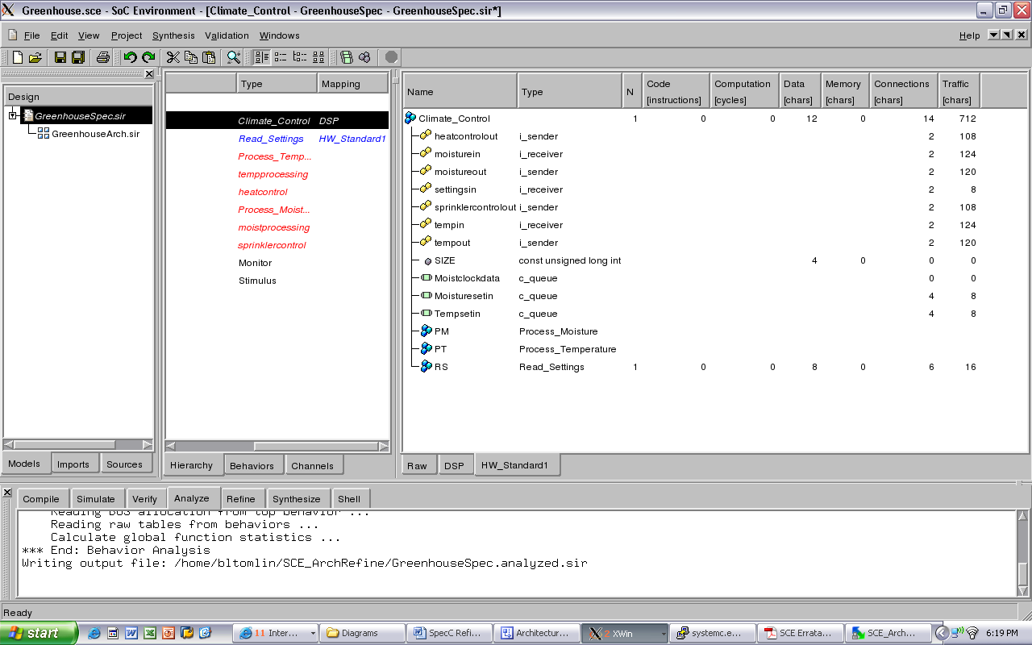
Figure 8. Profiling of HW for HW/SW Implementation
- Add synchronization – Did not need to add synchronization as there are no original behaviors that now cross component boundaries.
- Move communication – Channels/variables used globally are moved by the SCE refinement either globally to the embedded system as a whole or to each of the individual PEs (if only accessed on/by that PE). Corresponding ports/hierarchy are added to account for the additional communication wires between components.
Scheduling
- Serialize behavior hierarchy – Used the “Serialize Tree” to remove all concurrency among behaviors and provide a sequential execution within the SCE tool.
Variable Partitioning
- Move variables into components – All variables stored locally by the SCE tool in the PEs for which accesses for computation are required.
- Add communication channels – SCE tool added communication channels at individual PE level and at top-level “Climate Control” to account for additional communications channels created by the partitioning of behaviors on separate PEs.
- Update variable accesses – SCE tool separates variable interfaces such that all variables are accessed via read/write commands to a corresponding channel.
- Optimize communication and synchronization – SCE tool performs channel refinement during the architectural refinement stage. Communication channels are removed if they are not accessed inside a particular PE, and are moved globally if accessed by more than one PE.
Channel Partitioning
- Estimate channel metrics – Used the SCE tool to provide estimated channel metrics (prior to bus selection and additional communication refinement).
Architectural Model Guidelines
- Create high level structure – Top level behaviors include the physical characteristics of the PEs selected for the architecture model. All of the top-level structure (at “Climate Control”) specifies the physical structure of the proposed greenhouse environmental control system.
- Sequentialize component functionality – Used the SCE to sequentialize all of the behavior executions. Used the “Serialize Tree” functions to indicate the order in which previously parallel functions should execute.
- Specify global communication – No variables or storage within bus channels. All of the channels have been moved globally, either at the individual PE level or at the platform (ie. all PEs) level.
- Annotate estimated metrics – These example metrics are captured above. Communication delays were added to the behaviors and channels to simulate closer to actual timing of the system.

